Web design: Responsive websites using media queries

* **mobile (or handheld):** A computing device that has screen size smaller than usual desktop computers and are easily portable and fits in single hand of normal person.
* **viewport**: the viewable screen size of any computing device like desktop, laptop, tablet, mobile phone
* **cascading:** refers to the addition two or more components (definition rules of css in case of web design) into a single major component such that they add up if there is any difference or the latest one will overlap the previous one if they are exactly same

* **breakpoint:** the point where change in viewport size affects the loading of media query
* **media-query**: are useful when you want to modify your site or app depending on a device's general type (such as print vs. screen) or specific characteristics and parameters (such as screen resolution or browser viewport width).
* **min-width:** this defines the rules of media query after viewport is equal to or greater than defined min-width

* **max-width:** this defines rule until viewport is less than or equal to defined max-width
* **aspect ratio:** it is the ratio of length by width of any 2D figures
* **orientation:** this is method of viewing any-thing, on rectangular mobile device. Are of two types: portrait and landscape
* **mobile-first design:** In today’s world, access of any web based application is mostly done through mobile devices rather than from desktop/laptop computer as in earlier days. So currently most of the new web designs are first made for mobile devices and later for bigger devices.

[WWW.APPLE.COM](http://WWW.APPLE.COM)

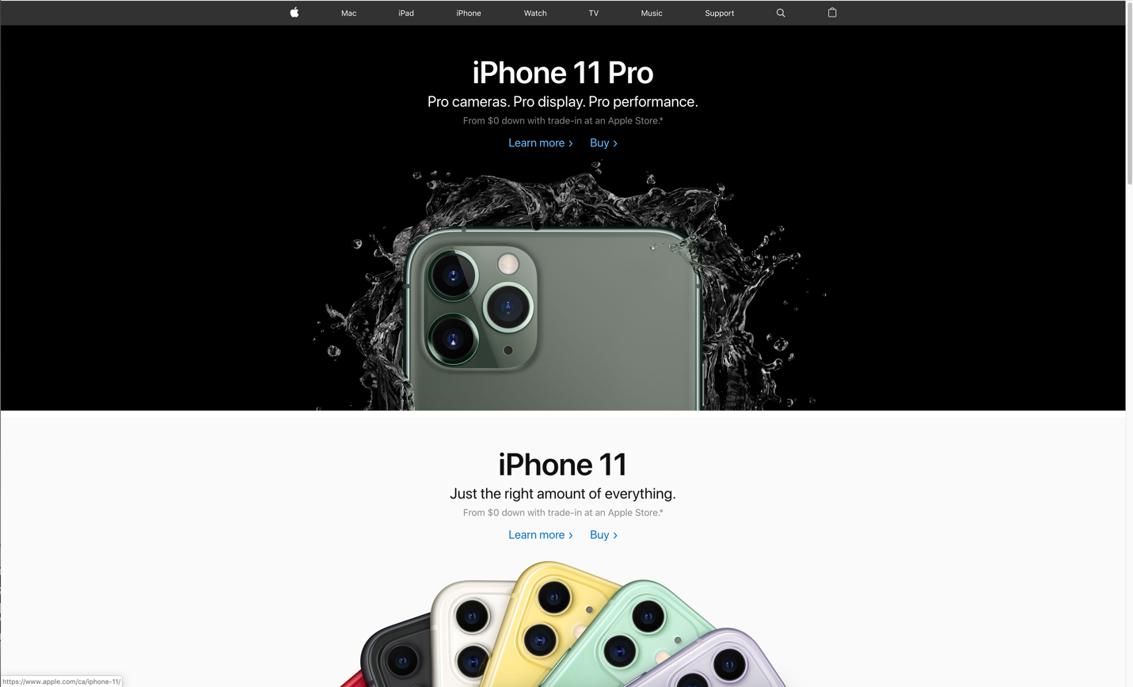

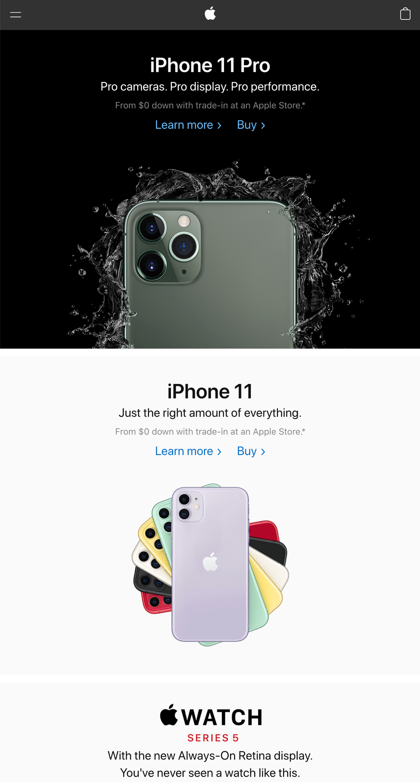

As we can clearly see that the website view changes multiple things as the size of viewport is changed. Some of the major changes are

Menu: In large viewport the menu is actual navigation bar where various navigating components are clearly visible and links to various other respective pages. In small viewport, the navigation bar combines to give dropdown menu bar on left top corner whereas logo moves to the center.

Overall content: the available text content are made flexible enough to fit the width of the viewport and always uses 100% of the available width. Also the font size in small view is small and larger view has large.

In addition the loading of images (including the background) changes according to the viewport size. At the same time some containers are block in small view and become inline-block in case of large view.

[www.playstation.com/en-ca/](http://www.playstation.com/en-ca/)





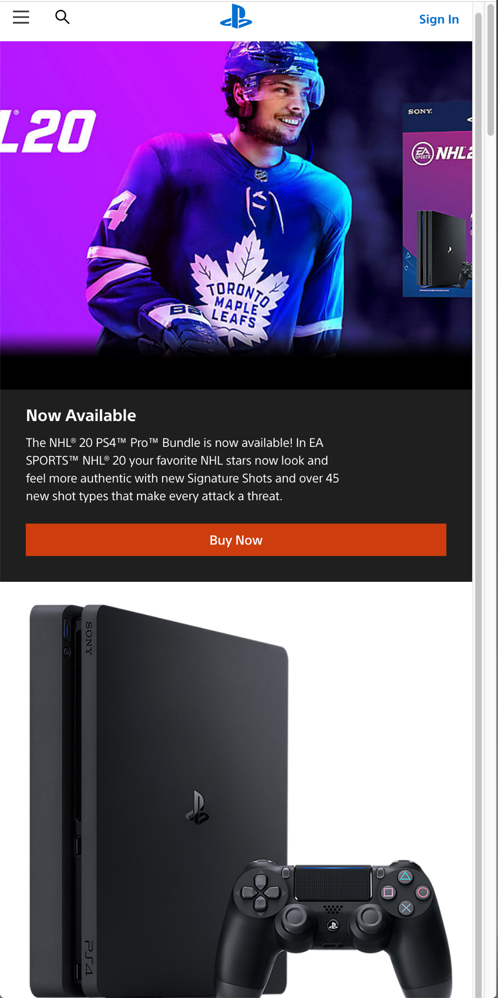

We can see from above pictures that this website has three major breakpoints for the design to be responsive

Menu: the menu on larger view is navigation bar with major components displayed to give link or navigation to various other pages. While in middle size, the view remains same but the font size changes to some what smaller size than previous. On the other hand, in mobile view the navigation bar changes to become dropdown menu that includes all the navigation link options.

Overall content: the font size is different on various viewport size. Also the images are maintained to be responsive on basis of viewport. The web page cover ups 100% width of the viewport in all cases.